

***Centre for Continuing Education***

420-WA5-AB

Foundations of Web Development

## Lab Assignment 1 Due: May 29, 2023

**Worth: 10% *Late assignments are not accepted.***

Open the File_A document

* If your ruler isn’t displayed, on the View tab, in the Show group, select the check box for Ruler.
* On the Home tab, in the Paragraph group, click the Show/Hide ¶ button to view the formatting marks.

1. Note the single tab between all of the list items and how the amounts don’t align correctly. Place your cursor in one of the lines in the list and note the left manual tab stop in the ruler.

## TIP The list doesn’t have additional formatted space between the list items. This is because the built-in No Spacing style has been applied to all paragraphs in the list.

1. To set a decimal tab and align the amounts, select the list headings and all employee information.

## TIP To select the list data, place your mouse to the left of the list items, point at the list headings, and then click and drag down through Michiyo Sato’s data.

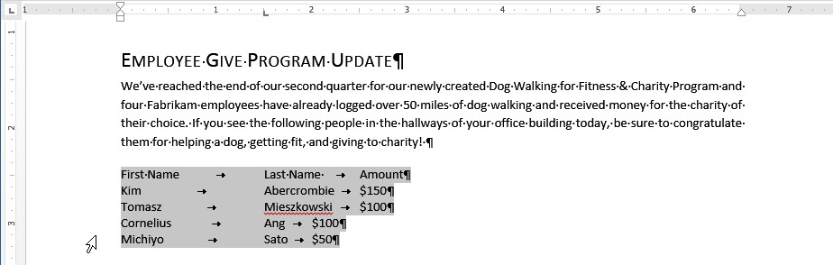

1. At the intersection of the vertical and horizontal ruler, click the tab selector until a Decimal Tab is displayed.

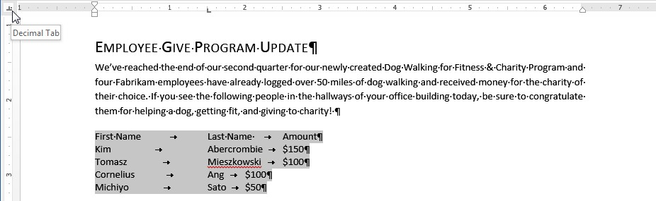

1. On the ruler, click the 5-inch or 13-centimeter mark to set the decimal tab and note how the amounts correctly align.

## IMPORTANT Make sure you click on the ruler and not above or below it.

1. To reduce the amount of space between the last names and amounts, with the list selected, drag the decimal tab to the 3.5-inch or 9-centimeter mark.

## TIP For precision, hold the Alt key while dragging to view measurements on the ruler instead of the tick marks.

1. To demonstrate how numbers align to the decimal point position, change the first amount in the list to

$150.50.

1. Press Ctrl+End to move your cursor to the end of the document and remove the text selection.

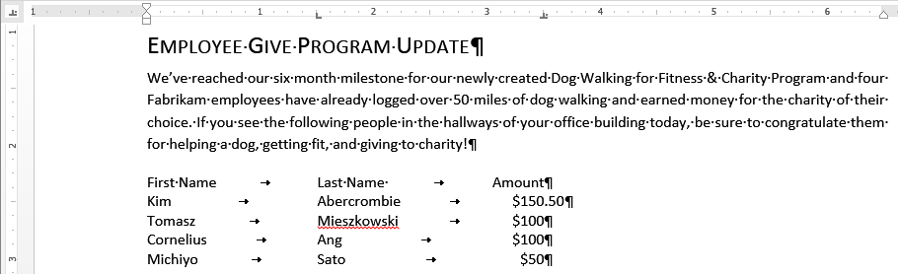

1. To set a manual tab for the memo heading, move the cursor after the word TO: near the top of the document.
2. Click the tab selector until a left tab is displayed, and set a left tab at the 1-inch or 2.5-centimeter mark.
3. Press the Tab key, enter All Employees, and then press Enter.
4. Enter FROM:, press the Tab key, and then enter Human Resources.

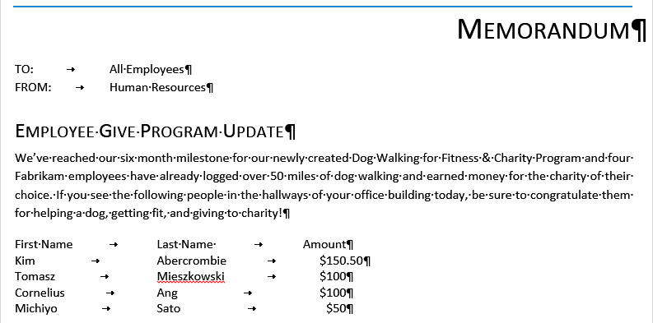

Turn off the display of formatting marks, save as **Lab1_1** and then close the document.

Open the File_B document

* 1. Select the list of names, including the headings, and on the ruler, at the 3.5-inch mark, drag the decimal tab off the ruler to delete it.

## TIP If you have difficulty deleting the decimal tab, point to the tab and watch for the ScreenTip. After it appears, click the tab and drag it up or down off of the ruler.

* 1. On the Insert tab, in the Tables group, click the Table button, and then click Convert Text to Table.
  2. In the Convert Text to Table dialog box, note that the number of rows and columns match the tabbed selection, and near the bottom, under Separate text at, the Tabs option is selected.
  3. Click OK to convert the tabbed list to a table.
  4. To view how the table will be resized to fit your text area, on the Page Layout tab, in the Page Setup group, click the Orientation button, and then click Landscape.

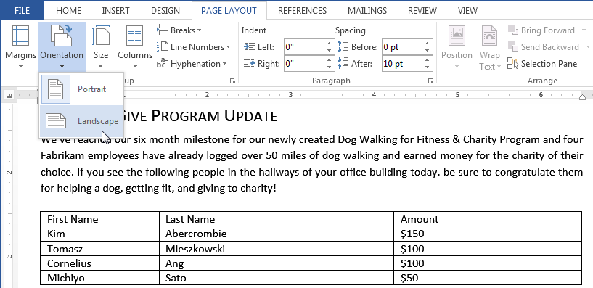

* 1. Change the page orientation back to portrait.

Save as **Lab1_2** and then close the document.

Open the File_C document

* To make the document easier to navigate, on the View tab, in the Show group, select the Navigation Pane check box.
* In the Navigation pane, click Nature Friendly Products.

1. Place your cursor in the paragraph with the text Sustainable products.
2. On the Home tab, in the Styles gallery, click Heading 2.

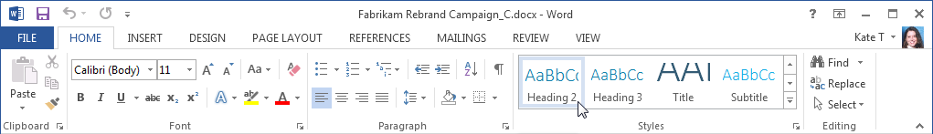

1. Apply the **Heading 2** style to the following paragraphs: **Other materials**, **Fixtures and appliances**, and

**Miscellaneous**.

**KEYBOARD SHORTCUT** After applying the first Heading 2 style, place your cursor in the next paragraph that needs the Heading 2 style applied and press F4 to repeat your last action of applying the Heading 2 style.

1. To change the font color and font size for all paragraphs with the **Heading 2** style applied, select **Sustainable products**.

**TIP** You can select any paragraph that has the Heading 2 style applied.

1. On the **Home** tab, in the **Font** group, click the arrow next to **Font Color**, and from the color palette, select the last color in the top row, **Teal, Accent 6**.

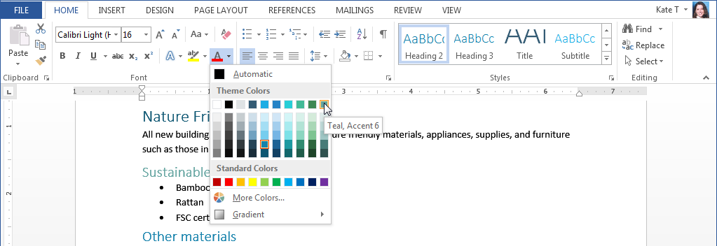

1. Change the font size from 16 points to 14 points.
2. To update all Heading 2 paragraphs to the new font color and font size, with Sustainable products still selected, on the Home tab, in the Styles gallery, right-click Heading 2, and then click Update Heading 2 to Match Selection.

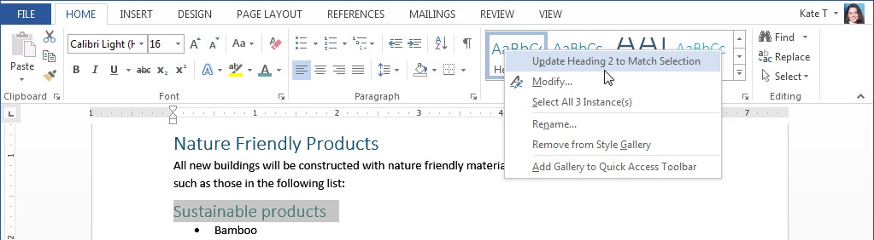

1. Move the cursor to the top of the document.

## KEYBOARD SHORTCUT Press Ctrl+Home.

**TIP Your cursor should be in the title paragraph, Rebrand Campaign. Because you’re making a paragraph formatting change, the title doesn’t need to be selected.**

1. To center the title, on the Home tab, in the Paragraph group, click Center.

## KEYBOARD SHORTCUT Press Ctrl+E.

1. To add formatted space before the first paragraph and to position it vertically on the page, on the Page Layout tab, in the Paragraph group, change the Before spacing to 228 points.

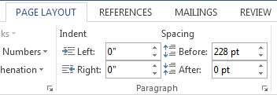

## TIP You can click the up arrow to change the spacing or enter 228 in the text box, and then press the Enter key. You don’t need to enter pts, because Word will add that for you.

1. In the Styles gallery, update the Title style to match your current selection.
2. Scroll through the document and view the formatting changes.

Save the document as **Lab1_3** and close the document.

Open the File_D document

# The purpose of this task is to create a business report with a consistent style.

1. Select all of the contents in this file. Copy and then paste it two times so that you have 3 copies of the same information.
2. Insert page breaks so that each Job Title starts on a new page.
   1. Search for 3 jobs for a Full Stack Developer, or similar, that would be an entry level position or requires less than 5 years of experience. The location/city of the job must be relevant for you in 2024.
   2. Replace or add the information as specified in the Word document so that it contains information about 3 jobs.
3. Use the style Heading 1 for the job title, use Heading 2 for the company name, and use Heading 4 for the other headings. Update or modify the styles for Heading 1 and Heading 2 to a style of your preference. Standardize the style for the report.
4. Use the spell check and grammar check in Word for the paragraph where you give the reason why you might recommend this job.
5. Insert a title page and an Automatic Table of Contents for this report.
6. Add a footer containing the page number. Do not have the page number show on the title page (use the checkbox for different first page.)
7. Use a footnote on the Job Description to reference where you found the job advertised. For example: Indeed. Add another footnote with your name. For example. 2 Job selected by Your Name
8. Proofread, update styles as needed, then update the Table of Contents.

Save the document as **Lab1_4** and close the document.

Checklist for the document **Lab1_4**

|  |  |
| --- | --- |
| Title Page |  |
| Table of Contents (Automatic) |  |
| Job 1 – Job 2 – Job 3 |  |
| For each Job, a paragraph with your comments about the job. |  |
| Correct use of Styles for headings |  |
| Spell Check and Grammar Check |  |
| Page Numbers |  |
| Footnotes |  |
| Table of Contents is updated |  |

# Submit the 4 files for Lab Assignment 1 to the dropbox on Moodle for Lab Assignment 1.